Genesis Portal instructions

How to Use the MHS GENESIS Patient Portal

1. From the MHS GENESIS Patient Portal Dashboard, choose Messaging.

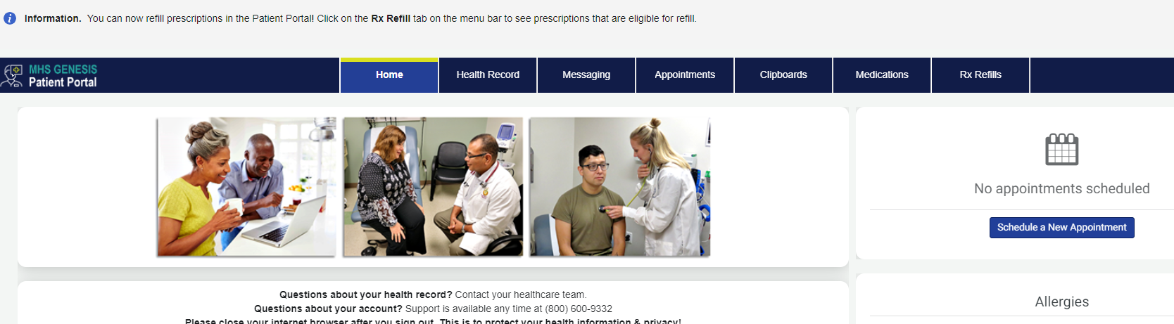

2. In the New Message menu, select "Send a message"
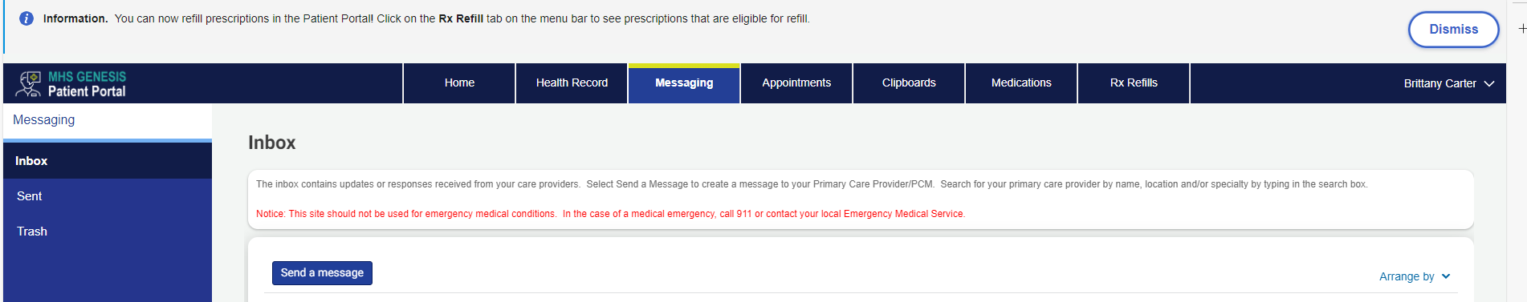
3. In the “To” field, search for our clinic name:
Travis Ophthalmology Refractive Clinic
4. Enter an appropriate subject: For example, “CRS Application” (if active duty) or “Dependent and Retiree Application for Refractive Surgery”, attach completed application and write your message.
5. Click Send

